ECE 211/212

Team Project: Hand-Washing Smart Watch

Gabrielle Hladik, Jana AlHuneidi, Garth Crawford, Zheng Zhang

July 12th, 2020

**Project Description**

With the prevalence of coronavirus, it is very important for everyone to develop good hygiene habits to prevent viruses.We decided to pursue the idea of creating a watch that would include a reminder of when to wash your hands, as well as other features including how long to wash your hands for, and telling the time. We thought that this would be a great project during the COVID-19 pandemic since we know that the demand for proper health-care related upkeep is very necessary at these times. By giving notifications like this and providing a timer to allow for the recommended washing time, people will be more inclined to practice good hygiene techniques and keep their good health.

Other alternative projects we proposed are included below in our design matrix. We were able to narrow down our decision by analyzing these given elements: the cost of materials, the complexity of the project, the desirability of it to the user, the efficiency, and the practicality. Our final idea scored a 5 on the difficulty as the original design will be very simple, but as time goes on, we will propose additional features and functions to be added.

In the design matrix below, we decided to rate the five characteristics of the project, such as difficulty and efficiency and others as shown in the table below. The higher the total score, the more it meets our needs- this includes how difficult it would be to implement the project, with 5 being the most desirible for our needs and 1 being the least desirable . When its score is 1, it is considered to be the most difficult, but when the score is 5, it is considered to be the easiest to achieve. In regards to the ‘cost’ design element, 5 was set as the least expensive and 1 as the most expensive. We wanted our project to be affordable for all users, while providing quality services. By using the design matrix, we were able to narrow down our project to the watch.

| DESIGN MATRIX | | | | | |  |
| --- | --- | --- | --- | --- | --- | --- |
| Design Decision | Design Elements | | | | | TOTAL |
|  | Difficulty | Cost | Desirability | Efficiency | Practical |  |
| **Gesture Controlled Robot** | 2 | 1 | 3 | 5 | 2 | 13 |
| **Pill Dispenser** | 3 | 2 | 5 | 5 | 5 | 20 |
| **Hand-Washing Reminder Watch** | 5 | 4 | 5 | 4 | 5 | 23 |
| **Automated Pet Feeder** | 4 | 3 | 5 | 4 | 5 | 21 |
| **Human Controlled Dino Game** | 3 | 3 | 2 | 3 | 5 | 16 |

**Project Requirements**

Our plan for this project is to create a basic watch with “smart” features that will help with hygiene techniques as well as send other reminders to the user, that will make their life easier and help to prevent COVID-19 from spreading. Below is more information pertaining to our proposed requirements for our project.

*L0 decomposition:*

For the design of the watch, we would have 3 inputs: the power, the switch input, and the vibration sensor. The output would be the LCD display that shows the time in either a 12 hour or 24 hour format, based on the preference of the user. The functions of the watch included telling the user the time, indicating how long the user should wash their hands for as well as when they should do so.

|  |
| --- |
| *Figure 1 - L0 Decomposition Blackbox of proposed watch* |

The project would be deemed successful if the watch is able to sense the movement of the user and initiate the 30 second countdown timer. In addition to this, the watch should be able to notify the user when they need to wash their hands. The watch shall potentially include the following functions:

* Shall set time to remind the user to wash the hand
* Shall have a clock function that displays the time on a 12-hour basis
* Shall have a timer that indicated to the user how long they must wash their wants for
* Shall be compact enough to be worn around the wrist
* May include the option of switching from a 12-hour clock to a 24-hour clock
* May have the ability to display the temperature in that given space, at that given time
* Shall Collect data of how often hands have been washed in a day; this would be done by transferring data to cloud or bluetooth or some other form so it could be seen on a device
* Shall be water resistant to some extent
* Shall have buzzers to remind the user needing to wash hands
* Shall have LED display status whether to wash hands

*Performance:*

* The Hand-Washing Reminder Watch shall act as a regular watch that can be worn on the wrist and has a time display of 12-hour clock. In addition, It shall also have water resistant material to make the watch waterproof to some extent .
* The Hand-Washing Reminder Watch shall have a Notification system, It means when the user uses a timer to set the specific time to remind him to wash his hands, the buzzer built in the watch shall make a sound. Besides LED shall also light up to remind users to wash their hands.
* The Hand-Washing Reminder Watch shall have a bluetooth enabled watch that can collect the data successful. It Shall collect data of how often hands have been washed in a day and shall view the data which collect by watch .

*Requirements/ Constraints*

* Compact Design- It is just a watch, the approximate area is 1.4x0.7 feet, which is convenient for storage and wearable around the wrist
* Usability- Like a regular watch with a 12-hour demo function, it may add options from a 12-hour clock to a 24-hour clock, and display the temperature in that given space at that given time
* Water Resistance- Considering that users who wash hands are inevitably exposed to water, we know that for the most effective prototype, we need to take into account the users environment, thus making the watch resistant to water damage.
* Easy Installation- Because the watch occupies a small space, it has limited parts, so it is very convenient for users to install. If the watch has a hardware problem, the user can dismantle it at any time to check and fix any issues.
* Notification system- This is the characteristic of the watch. It must have a timer to set the time to remind the user to wash his hands. At the same time, there will be a buzzer and an LED light that turns on to remind the user to wash their hands.
* Collection of Data- The watch is to have Bluetooth, and data is to be able to be collected via Bluetooth. This data would include the number of times the user washes their hands in a day, and time of the user’s hand washing each day.
* Upgradability- Users can program the product controller according to their own needs to achieve the effect of adding functions and upgrades. The watch will also have reserved space for the user to add components while keeping a sleek, compact design.

**Project Implementation**

*L1 Decomposition*

The watch will function as a regular watch which has a 12-hour and/or 24-hour display, while also reminding the user to wash their hands throughout the day and count down the recommended time of doing so. By setting a recommended amount of time for hand-washing, the buzzers will emit a sound to remind the user, and at the same time an LED light will light up, indicating to the user that it is time to wash your hands for x amount of minutes.



*List of Tasks*

* Make 12-hour clock display
* Make 24-hour clock display
* Make watch water resistant
* Test water resistant product (10 seconds completely submerged)
* Put together prototype (w/ buzzer & with LED)
* Create code for Notification system
* Make build of circuit
* Test prototype reminder feature
* Send reminder data to device/cloud
* create code for timing function of 20 seconds
* create code for activation method
* test the code on prototype

*General timeline*

Sprint 1:

For sprint 1, we plan to build a complete watch, which can be comfortably placed on the wrist like a regular watch and uses the LCD for the 12-clock display. We will begin to prepare for the second sprint to remind the user to wash their hand.

Sprint 2:

For sprint 2, we plan on adding a 24-hour clock option to the prototype, as well as a sensor that will sense when the user begins to wash their hands and will begin a 30 second timer, indicating how long the user should wash their hands for. This will be indicated by an LED that will turn on for 20 seconds or blink 20 times for 1 second intervals and add a buzzer to alarm at set time.

Sprint 3:

For sprint 3, we plan to add bluetooth or cloud capabilities to allow for data collection which will help us to analyze how often they are washing hands everyday and the efficiency. We will also test and perfect the function of the watch.

*Project Timeline*

The figure below shows our gantt chart along with the tasks that we plan to accomplish within the next 8 weeks of this project. The Gantt chart will be added and modified continuously with the follow-up projects.

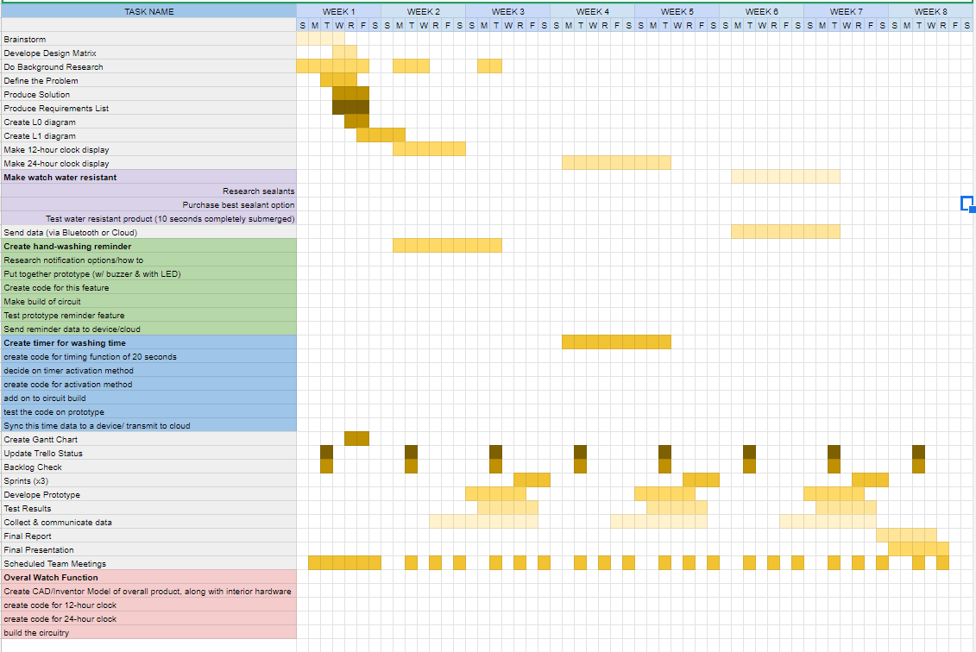

Specific task assignments such as the deadline of the task, who is responsible for what task, and so on, are intended to be organized with the use of Trello. We will continue to increase the tasks and adjust the responsible personnel according to the project progress. The following image below is a screenshot and link of our Trello board.

Trello: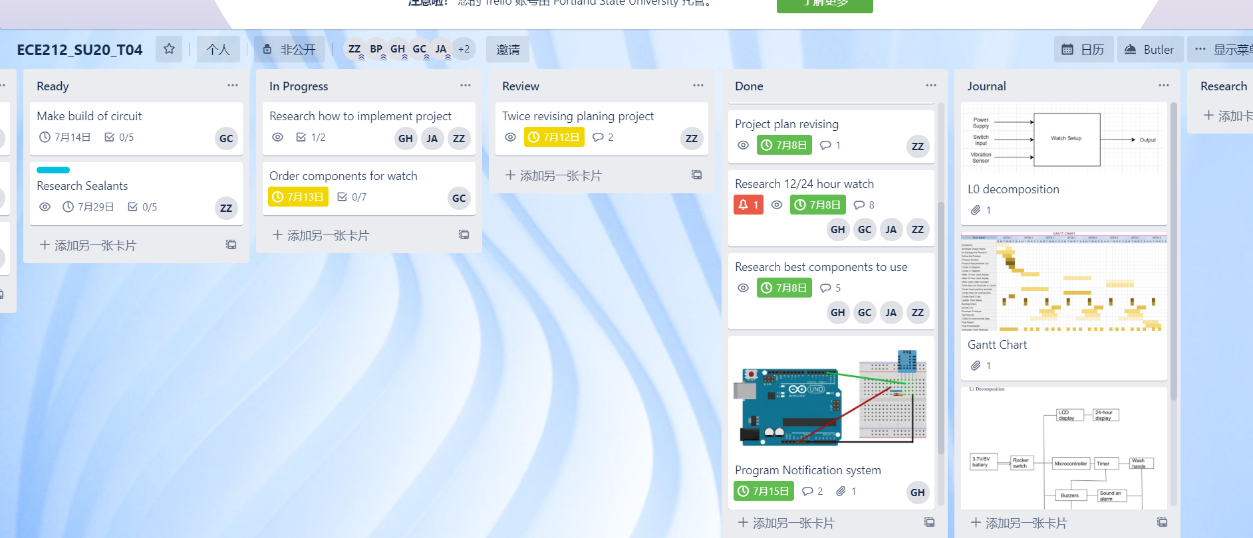

Trello Link: [*https://trello.com/b/wc9hacWC/ece212su20t04*](https://trello.com/b/wc9hacWC/ece212su20t04)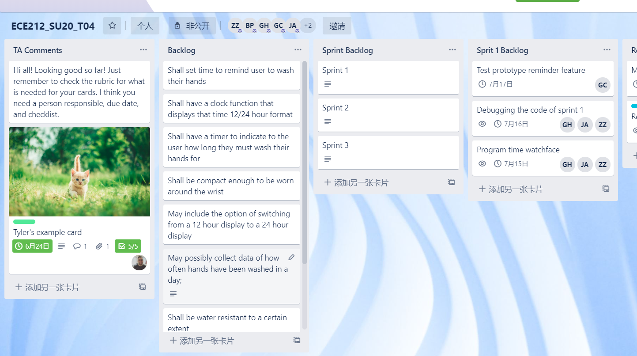

*Plan for Dividing and Conquering*

Gabrielle Hladik

* Project Design
* Programming
* Technical paper
* Debugging

Jana AlHuneidi

* Project Design
* Programming
* Technical paper
* Debugging

Garth Crawford

* Build the circuit
* Solve hardware problems
* Testing

Zheng Zhang

* Programming
* Solve hardware problems
* testing
* Technical paper

Due to the difficulty of different programming tasks, we currently decide to program the task together. With this method, we can maximize the strength of the team. For example, if we encounter a difficult task, our three programmers can solve it together, so that it will not cause a situation where one’s thinking is blocked and the problem cannot be solved for a long time. After the code is written, Zheng conducts software testing and then submits it to Garth for hardware testing. When encountering hardware problems such as poor circuit contact or component damage during hardware testing, Garth can communicate with Zheng to solve it. When the hardware is normal, the software When there is a problem, Garth will feedback the problem to janna or Gabrielle, they will immediately debug to ensure that the problem is resolved as soon as possible, and then handed over to zheng for software testing and then handed over to Garth for hardware testing until the function is realized.

*Summary*

All in all, we plan on creating a smart-watch that has the ability to change from a 12-hour clock to a 24-hour clock display, as well as indicate when, and for how long the user should wash their hands for. We also plan to make it possible for the data to be collected and transmitted via bluetooth to a device so the user would be able to track how often they were washing their hands each day. We decided to add on the hand-washing feature due to the current pandemic happening in the world. We realize that keeping good health and hygiene is of high importance at this time so we thought that this would be a great way to help people practice those habits

*All team members have contributed to this report, read it, and agree with its contents.*

**Reference**

Kiplagat (2018). “smart watch project.” Retrieved from

<https://www.academia.edu/37888349/smart_watch_project.docx>

Apple II Watch(n.d) retrieved from

<https://www.instructables.com/id/Apple-II-Watch/>**s**

DIY Hand Wash Reminder. (n.d.). Retrieved from

<https://create.arduino.cc/projecthub/Mukesh_Sankhla/diy-hand-wash-reminder-3b2ceb?ref=platform&ref_id=424_trending__beginner_&offset=28>

GodsTale, & Instructables. (2017, October 17). Make Your Own Smart Watch. Retrieved from <https://www.instructables.com/id/Make-your-own-smart-watch/>

“When and How to Wash Your Hands.” *Centers for Disease Control and Prevention*, Centers for Disease Control and Prevention, 2 Apr. 2020, [www.cdc.gov/handwashing/when-how-handwashing.html](http://www.cdc.gov/handwashing/when-how-handwashing.html)